**PROJECT REPORT**

ON

COLLEGES COMPARISON WEBSITE

Subject -: Web Technology

Submitted to:- Mr.Lavish Arora

**Subbmitted By:-**

**ROLL NO.**  **NAME**

1803010110 JATIN PAL

1803010*** SHIVANGI GANGWAR

1803010*** SIDDHANT NEGI

1803010*** RITIKA RAWAT

1. OBJECTIVES-:

The Summer Training Web development progrmn is very useful for all the students to prepare a project on any particular subject.

Our website is [b HYPERLINK "http://www.bharat/"harat](http://www.bharat/)colleges, we create website to comparison b/w colleges.

In our website user get information of determine about all colleges and the other purpose of this site was to know best colleges in India, . We have provided the email services.

1. BUSINESS SCENARIO -:

The  students /parents  can  select  best  colleges for their bright future. We took an attempt to design an user friendly website which allows the user to have a preview of all our exclusive knowledge.

1. PROBLEM STATEMENT / CHALLENGES -:

During our attempt we faced various challenges out of which many were resolved through our team work , but some remain unsolved due to the reason that it involved other languages than HTML, CSS , JAVASCRIPT.

The things which we were unable to add in our project are:

1. Problem in animated part.

2. Online Feedback.

3. Not connected to the database .

D. COMPONENT / ACESSORIES FOR THE DEVELOPMENT-:

We have used the various applications that are involved in making of a very basic website .

Following are the languages which are used:

1. HTML 5

2. CSS (Cascading style sheet)

3. JavaScript

PLATFORM Used for the website making :

1. Notepad++

1. LIST OF ACTIVITIES FOR DEVELOPING THE PROJECT

Being the website of a online knowledge about colleges , we kept some factors in mind and then structured the website using HTML. Major part of the website designing is done using CSS and when we felt the urgency to use Java Script , we used it as well.

The website that a user can see, will initially show the main page which portrays about the offers and interframe for the user.

The main page will also show the name of the Website along with the caption line.

Main page contains menu which would lead us to various other aspects of the website like forms ,about the website, how to contact ,forms,etc..

There are various forms linked on the main page like sign-in form, Contact us ,

About the website , sign-upforms, etc.

The blogs are also being kept in mind while designing the website.

Our team worked very wwell and all are supported to each other.

1. RESULTS AND DISCUSSION:

On the completion of the knowledge about colleges. We are able to view a user friendly website for a which offers us options to explore more about the colleges.

G. CONCLUSIONS AND RECOMMENDATIONS:

We were very much able to meet the aspects that we had already imagined but nothing comes out to be perfect everytime .

On completion of the project we get a lovely website ,but we all hope that it might contained the following thing:

We wished to have an online knowledge about colleges website which gives us an view of the various colleges in the India ,but unfortunately the animations didn’t work.

We wished to have a proper separate page of every college form that we were not able to make.

We wished to have a dynamic website but it required knowledge of other languages also .

Thanking You!

For giving us this opportunity.

Homepage

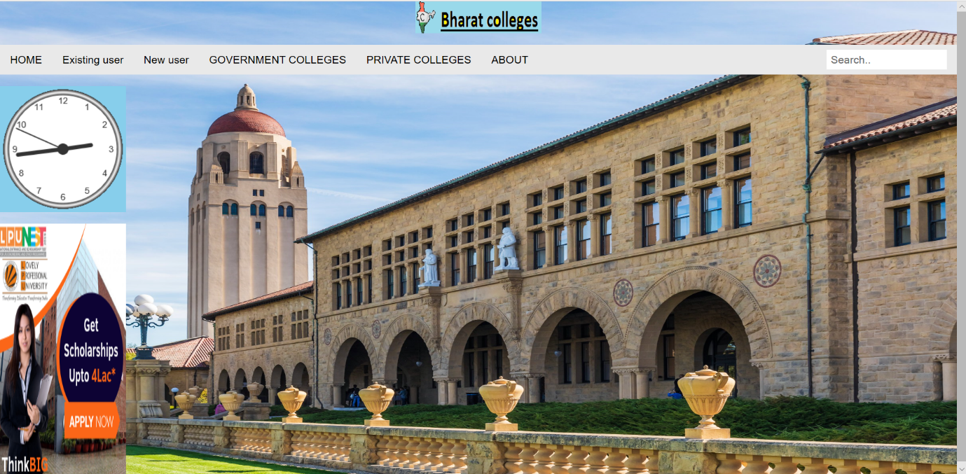

Existing User

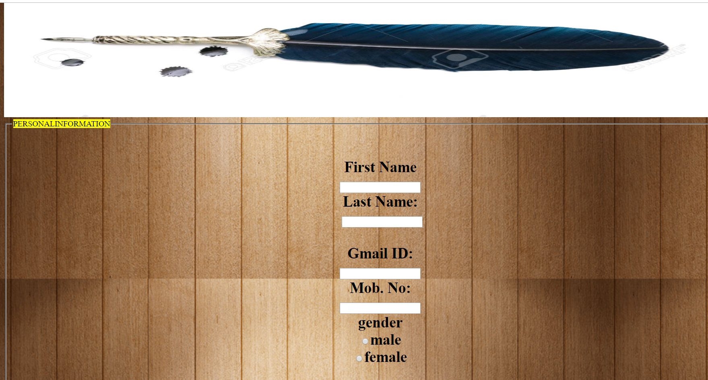

New User

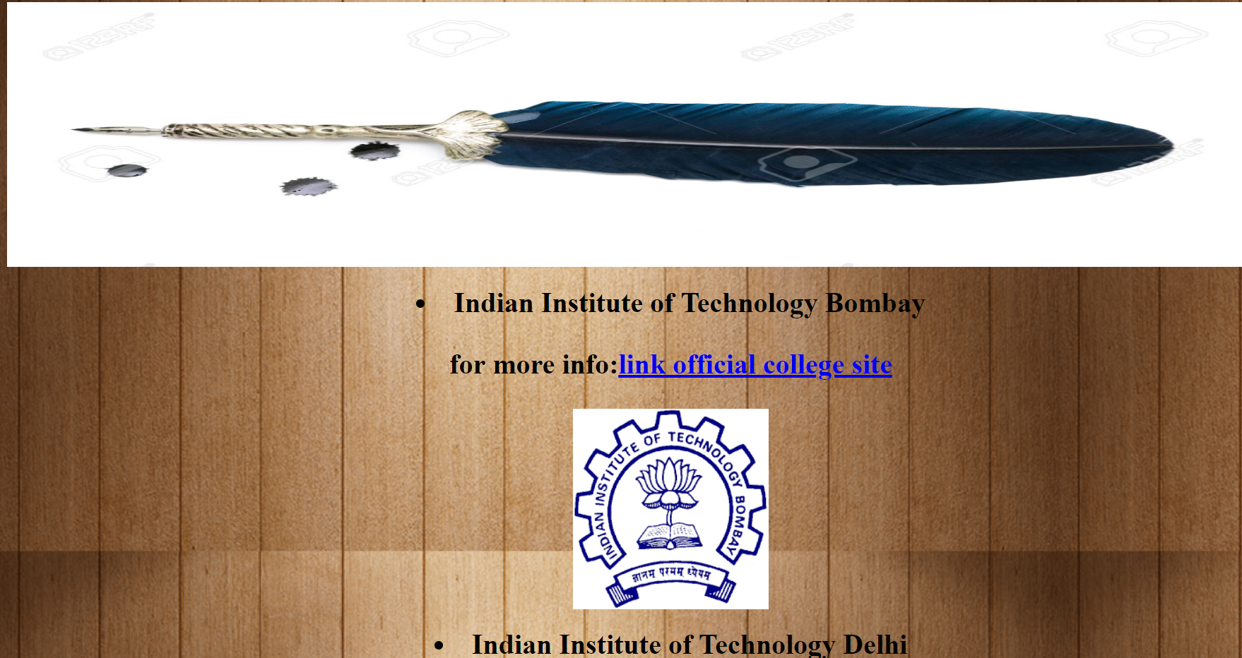

Private Colleges

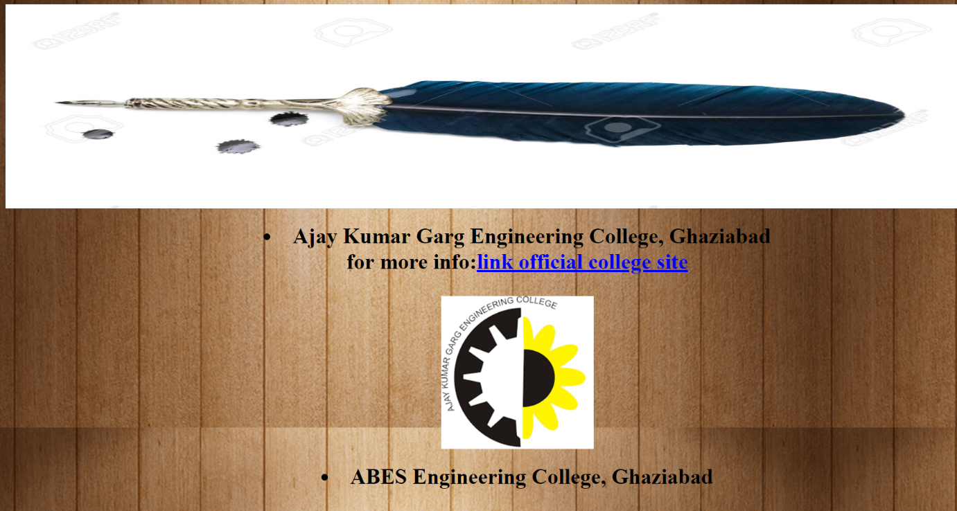

Government colleges

